Data Sheet
Product Information
Product Name | : | Recombinant Human Stem Cell Factor (rhSCF)
Synonyms | : | Kit ligand,
Description | : | Recombinant human Stem Cell Factor produced in E. coli is an 18.4 kDa protein containing 165 amino acids. SCF is a hematopoietic growth factor that exerts its activity by signaling through the c-Kit receptor.  It is particularly important in the mast cell and erythroid lineages, but also acts on multipotential stem and progenitor cells, megakaryocytes, and a subset of lymphoid progenitors. SCF exists in soluble or transmembrane forms which appear to differ in function.
NCBI Accession No. | : | NM_003994.5
Amino acid sequence | : | MEGICRNRVTNNVKDVTKLVANLPKDYMITLKYVPGMDVLPSHCWISEMVV  QLSDSLTDLLDKFSNISEGLSNYSIIDKLVNIVDDLVECVKENSSKDLKKS  FKSPEPRLFTPEEFFRIFNRSIDAFKDFVVASETSDCVVSSTLSPEKDSRV  SVTKPFMLPPVA
Molecular Mass | : | 18.55 kDa (165 aa)
Protein Tags | : | No tagging
Source | : | E. coli.
Cat. No. | : | JW-H003-0010, JW-H003-0025, JW-H003-0050, JW-H003-0100, JW-H003-0250, JW-H003-0500, JW-H003-1000
Storage | : | Should be at ≤ -70 ℃ as undiluted aliquots of handy size. Avoid repeated freezing and thawing.
Cross Reactivity | : | Monkey

Quality Control
Test items |  |  |  | Specifications
Appearance |  |  | : |  | Clear, colorless liquid
Purity |  |  | : |  | Greater than 98 % by RP-HPLC and SDS-PAGE
Specificity |  |  | : |  | Using Western blot, detection | 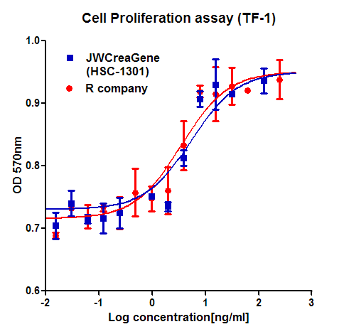
Concentration |  |  | : |  | 0.1 mg/㎖, Bradford method
Biological Activity |  |  | : |  | Determined by measuring the proliferation of murine TF-1 indicator cells.  The ED₅₀ is ≤ 5 ng/ml, corresponding to a specific activity of 0.2 × 10⁵ U/mg
Endotoxin |  |  | : |  | Less than 0.2 EU/㎍ as determined by the LAL method
Formulation |  |  | : |  | 40mM Tris-acetate, 5% glycerol (pH 8.0) without preservative or carrier proteins.
Stability |  |  | : |  | Stable for up to 12 months at -70 ℃. Stable for a month at 4 ℃.
Sterility |  |  | : |  | Sterilized through a 0.2 ㎛ membrane filter and packaged aseptically. Culture for 2 weeks, no growth

